Math Reviewer
Ratio and Proportion
Ratio and Proportion:
- Ratio – Comparison between two or more quantities showing how many times one value contains another. It expresses relative size, not absolute amount. It tells relationship in quantity, not total count.
- Proportion – An equation that states two ratios are equal. It shows that two relationships match.
- Extremes – The first and last terms (a and c)
- Means – The middle terms (d and b)
- Property – The product of the means equals the product of the extremes (ad = bc)
$$\frac{a}{b}=\frac{c}{d} or \left(a\right)\left(d\right)=\left(b\right)\left(c\right) or "a is to b"$$

Similar Figures
Similar Figures:
- Similar Figures – In geometry, similar figures are shapes that have the same shape but may have different sizes. This means their corresponding angles are equal, and their corresponding sides are in proportion.
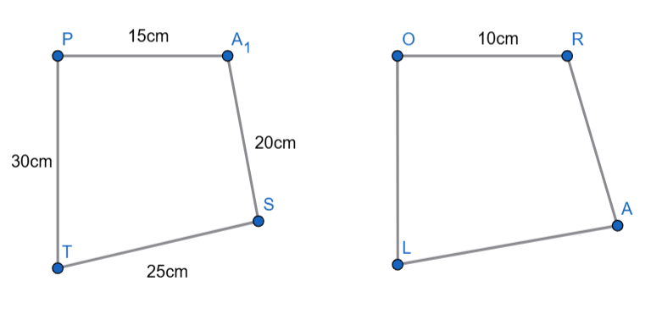
- Finding the Common Ratio or Scale Factor of □PAST and □ORAL:
$$\left(\frac{PA}{OR}=\frac{AS}{RA}=\frac{ST}{AL}=\frac{TP}{OL}\right)= \left(\frac{15}{10}=\frac{20}{RA}=\frac{25}{AL}=\frac{30}{OL}\right)$$
$$\frac{15}{10}=\frac{3}{2} (scale factor is\frac{3}{2})$$
- Finding the Missing Length of □PAST and □ORAL:
$$RA=\left(\frac{15}{10}=\frac{20}{RA}or\left(15\right)\left(RA\right)=(10)(20)\right)=\left(\frac{15RA}{15}=\frac{200}{15}\right)=\frac{40}{3}centimers$$
$$AL=\left(\frac{15}{10}=\frac{25}{AL}or\left(15\right)\left(AL\right)=(10)(25)\right)=\left(\frac{15LA}{15}=\frac{250}{15}\right)=\frac{50}{3}centimeters$$
$$OL=\left(\frac{15}{10}=\frac{30}{OL}or\left(15\right)\left(OL\right)=(10)(30)\right)=\left(\frac{15OL}{15}=\frac{300}{15}\right)=20centimeters$$

- Finding the Perimeter of □PAST and □ORAL:
$$□PAST=\left(PA+AS+ST+TP\right)=\left(15+20+25+30\right)=90centimeters$$
$$ORAL=\left(OR+RA+AL+LO\right)=\left(10+\frac{40}{3}+\frac{50}{3}+20\right)=\left(10+\frac{40}{3}+\frac{50}{3}+20\right)=60 centimeters$$

- Finding the Ratio of the Perimeter:
$$OP=\frac{P□PAST}{P□ORAL}=\frac{90}{60}=\frac{3}{2}$$

Theorem Formulas:
- Similar AA Theorem – $180°-\left(x°+y°\right)$
- Similar SSS/SAS/HL/LL Theorem - $\frac{a}{b}=\frac{c}{d} or \left(a\right)\left(d\right)=\left(b\right)\left(c\right)$

Theorems:
- Isosceles Triangle Theorem – If two sides of a triangle are equal, then the angles opposite those sides are also equal. This explains why base angles in an isosceles triangle are always congruent.
- Converse of Isosceles Triangle Theorem – If two angles of a triangle are equal, then the sides opposite those angles are equal. This helps identify an isosceles triangle by looking at its angles.
- Unequal Angles Theorem – In any triangle, the larger side is opposite the larger angle, and the smaller side is opposite the smaller angle. This shows the relationship between side length and angle size.
- Converse of Unequal Angles Theorem – The larger angle is opposite the longer side, and the smaller angle is opposite the shorter side. This is used to compare sides by examining angle measures.
- Exterior Angle Theorem – The exterior angle of a triangle is equal to the sum of the two remote interior angles. It is useful for finding missing angles without knowing all interior angles.
- Triangle Sum Theorem – The sum of the interior angles of a triangle is always 180°. No matter the shape or size, all triangle interior angles add up to 180°.
- Triangle Inequality Theorem – The sum of any two sides of a triangle must be greater than the third side. This determines whether three given lengths can form a triangle.
- Right Triangle Pythagorean Theorem – In a right triangle, a² + b² = c², where c is the hypotenuse. It is used to find missing side lengths in right triangles.
- Converse of Pythagorean Theorem – If a² + b² = c² for a triangle, then the triangle is a right triangle. It is used to verify whether a triangle has a right angle.

Trigonometry
Pythagorean Theorem:
- Pythagorean Theorem – Is a rule in geometry that applies only to a right triangle (a triangle with one 90° angle). In a right triangle, the square of the length of the hypotenuse is equal to the sum of the squares of the lengths of the other two sides.
$$a^{2}+b^{2}=c^{2}$$
$$a = length of the first leg$$
$$b = length of the second leg$$
$$c = length of the hypotenuse (the side opposite the right angle and always the longest side)$$

The Six Trigonometric Ratios:
- Trigonometric Ratios – Trigonometric ratios describe the relationship between angles and side lengths in a right triangle.
- Sine $(sin θ)$ – The ratio of the Opposite side to the Hypotenuse in a right triangle.
- Cosine $(cos θ)$ – The ratio of the Adjacent side to the Hypotenuse.
- Tangent $(tan θ)$ – The ratio of the Opposite side to the Adjacent side.
- Cosecant $(csc θ)$ – The reciprocal of sine, ratio of Hypotenuse to Opposite.
- Secant $(sec θ)$ - The reciprocal of cosine, ratio of Hypotenuse to Adjacent.
- Cotangent $(cot θ)$ - The reciprocal of tangent, ratio of Adjacent to Opposite.
SOH-CAH-TOA | CHO-SHA-CAO
$$sinθ=\frac{Opposite}{Hypotenuse}$$ | $$cscθ=\frac{Hypotenuse}{Opposite}$$
$$cosθ=\frac{Adjacent}{Hypotenuse}$$ | $$secθ=\frac{Hypotenuse}{Adjacent}$$
$$tanθ=\frac{Opposite}{Adjacent}$$ | $$cotθ=\frac{Adjacent}{Opposite}$$
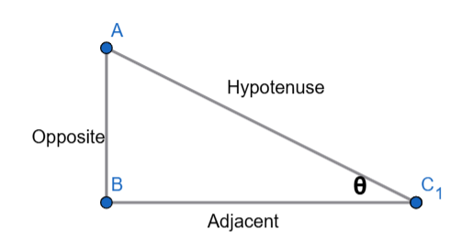 | 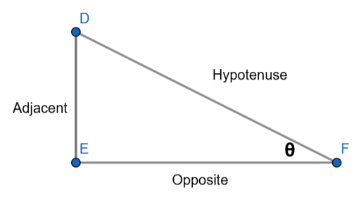
THIS IS NORMAL | (THETA SHOULD BE AT TOP)

Reciprocal Definition Rules
$$csc\left(θ\right)=\frac{1}{sin\left(θ\right)}$$ | $$sec\left(θ\right)=\frac{1}{cos\left(θ\right)}$$ | $$cot\left(θ\right)=\frac{1}{tan\left(θ\right)}$$

Special Angles:
- Special Angles – Special angles are specific angle measures whose sine, cosine, and tangent values can be expressed as exact fractions and radicals instead of decimals.
- Equilateral Triangle – 30° & 60°
- Isosceles Right Triangle – 45°
- Axis Angles on the Coordinate Plane – 0° & 90°
30°–60°–90° Triangle | 45°–45°–90° Triangle
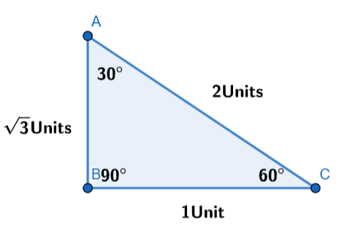 | 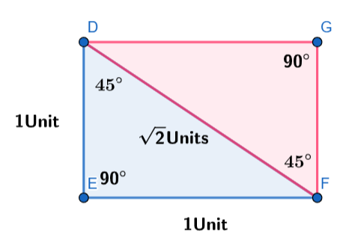
$$a^{2}+b^{2}=c^{2}$$  $$a^{2}+1^{2}=2^{2}$$  $$a^{2}=4-1$$  $$\sqrt{a^{2}}=\sqrt{3}$$  $$\sqrt{a^{2}}=±\sqrt{3}$$ | $$a^{2}+b^{2}=c^{2}$$  $$1^{2}+1^{2}=2^{2}$$  $$1+1=c^{2}$$  $$\sqrt{2}=\sqrt{c^{2}}$$  $$±\sqrt{a^{2}}=c$$

Ratio | 0° | 30° | 45° | 60°
sin θ | 0 | 1/2 | √2/2 | √3/2
cos θ | 1 | √3/2 | √2/2 | 1/2
tan θ | 0 | √3/3 | 1 | √3
csc θ | undefined | 2 | √2 | 2/√3
sec θ | 1 | 2/√3 | √2 | 2

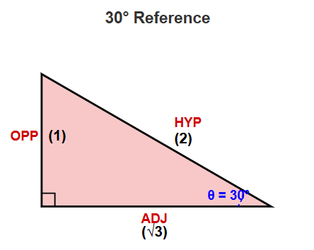 | 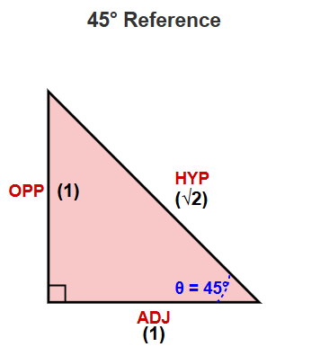 | 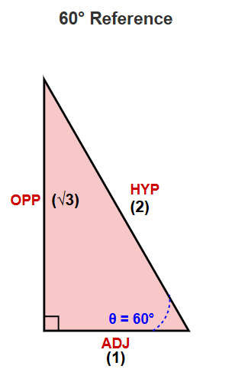
Angles of Elevation and Depression:
- Angle of Elevation – The angle of elevation is the acute angle formed between the horizontal line at the observer’s eye level and the upward line of sight toward an object positioned above the observer’s vertical height.
- Angle of Depression – The angle of depression is the acute angle formed between the horizontal line at the observer’s eye level and the line of sight directed downward toward an object located below the observer’s vertical position.

Degrees, Minutes, and Seconds (DMS)
Degrees, Minutes, and Seconds (DMS):
- Degrees, Minutes, and Seconds (DMS) - DMS is a way of expressing angles, used in geometry, navigation, maps, and astronomy. It splits an angle into three parts:
- Degrees (°) – the largest unit.
- Minutes (′) – smaller than a degree, 1/60 of a degree.
- Seconds (″) – even smaller, 1/60 of a minute, or 1/3600 of a degree.
$$Angle=Degrees°Minutes'Seconds''$$

Formulas:
DMS to Decimal Degrees | Decimal Degrees to DMS
$$Decimal Degrees=Degrees+\frac{Minutes}{60}+\frac{Seconds}{3600}$$ | $$Degrees=Integer part of DD$$  $$Minutes$$  $$Minutes=Decimal of Integer of Degrees×60$$  $$Seconds=Decimal of Integer of Minutes×60$$

Radians:
- Radians – A radian is a way of measuring angles based on the circle’s radius, not arbitrary divisions like degrees. One radian is defined as the angle at the center of a circle in a plane that is subtended by an arc whose length equals the radius of the circle.
Radians to Degrees | Degrees to Radians
$$\frac{radians}{1}×\frac{180}{π}$$ | $$\frac{θ}{1}×\frac{π}{180}$$

True Bearings
Bearings:
- Bearings – A bearing is a way of describing the direction of one point relative to another. It tells you which way to go from one location to reach another. Bearings are measured clockwise from the north direction.
- $North=0° or 360°$
- $East=90°$
- $South=180°$
- $West=270°$

